Project 1 — CAPACITI Online Register & WFH Application

Main goal
We are going to build a web application where:
Candidate can
- Signs in
- Records attendance
- Gives date/time/location
- Submits WFH request
- Tracks submitted requests
Tech Champion / Mentor
- Signs in
- Views attendance submissions
- Reviews WFH requests
- Tracks their status

Users / Actors
2 main actors:
- Candidate
Candidate kufuneka akwazi:
- Sign in
- Record attendance
- Select attendance status
- Capture date
- Capture time
- Capture location
- Submit WFH request
- Give WFH date
- Give reason
- Add supporting information
- View submitted attendance
- View submitted WFH requests

- Tech Champion / Mentor
Tech Champion/Mentor kufuneka akwazi:
- Sign in
- View candidate attendance submissions
- Track attendance
- View WFH requests
- Review WFH requests
- Update/request status where appropriate

UML DIAGRAMS
- Use Case Diagram
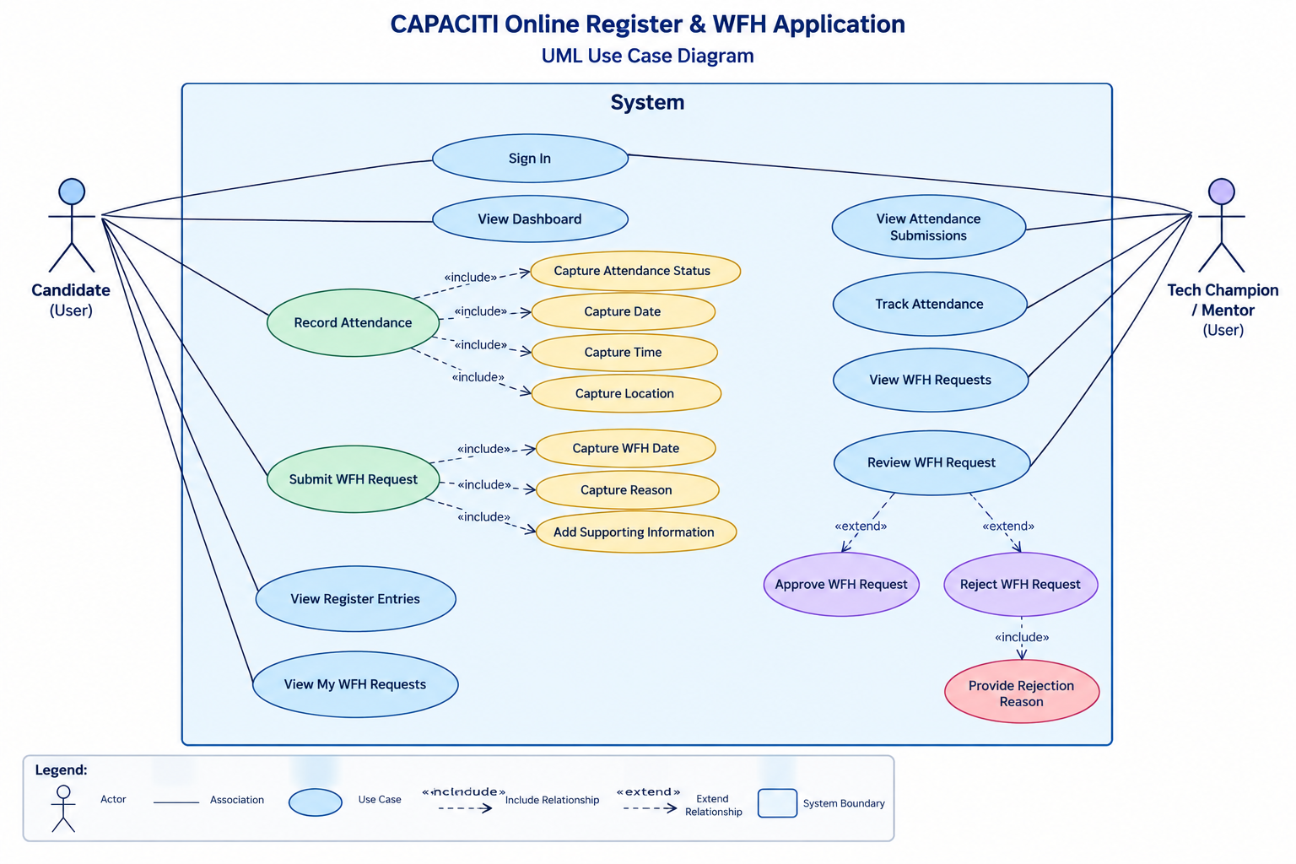
Figure 1 CAPACITI WFH USE CASE DIAGRAM ILLUSTRUATING THE COMMUNICATION BETWEEN THE USERS AND THE SYSTEM, DESIGNED USING DRAW.IO.

- Candidates_Attendance_Activity_Diagram
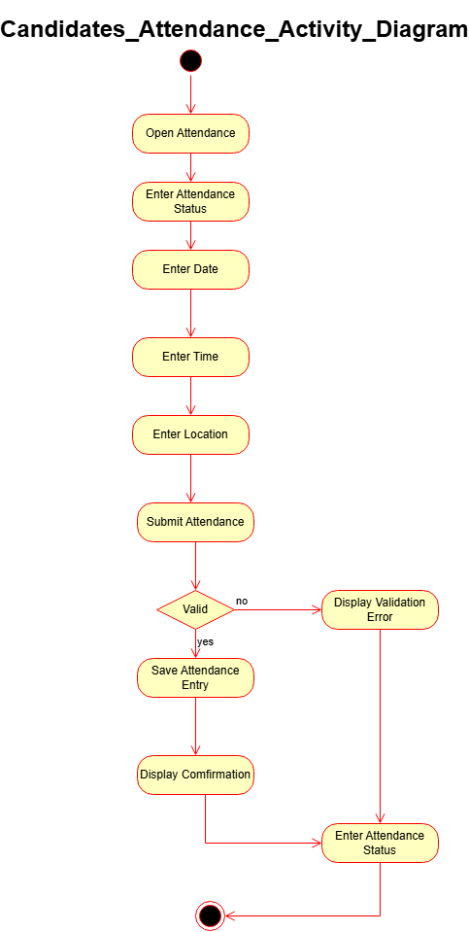

- Candidates_WFH_Request_Activity_Diagram

